**Production Trelloboard Sprint tracking**

**Backlog/ Preproduction Board:**

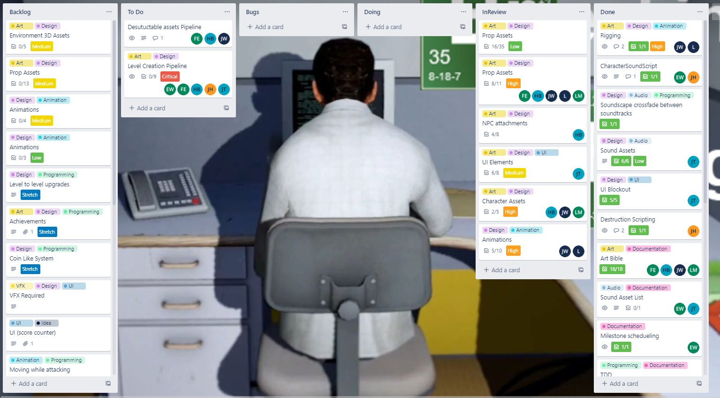

**Sprint 1:**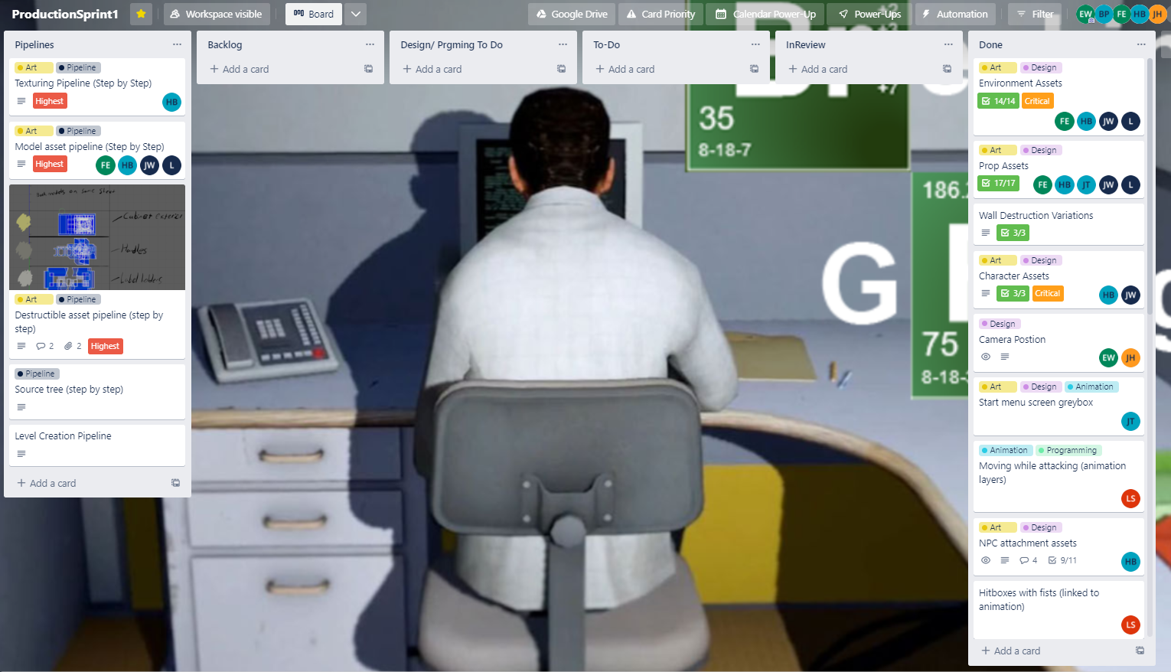

**Sprint 2:**

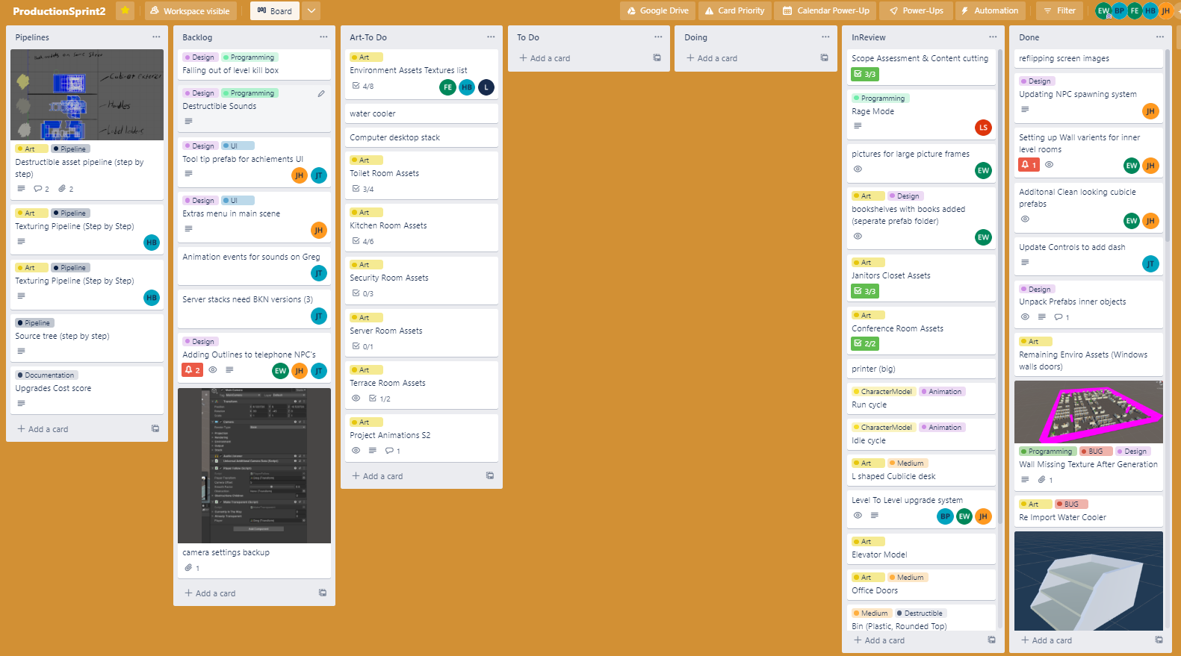

**Sprint 3:**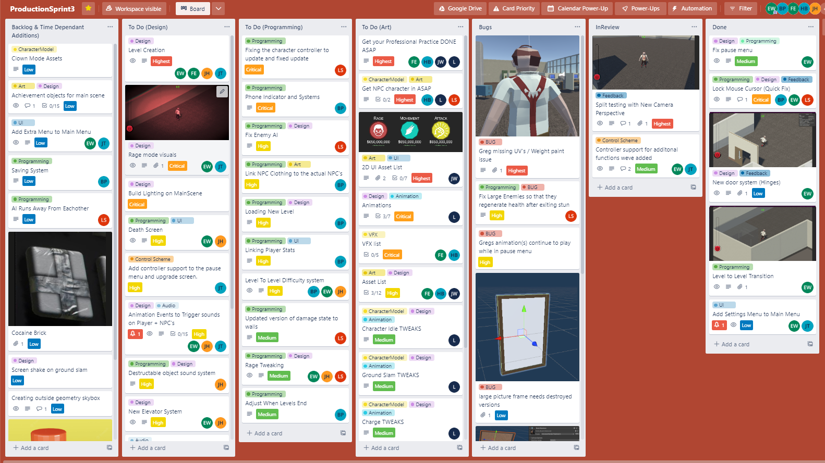

**SourceTree:**



